**Topics to be covered for Sessional 01 and sample questions**

1 – Recursion

2 – Dynamic Memory Allocation

3 – iostreams and exceptional handling

4 – Singly Linked list using struct and pointers

5 – Linked List using classes and objects

6 – Abstract Data Types

All lecture slides and sample code

Example Question

Q1 The following code print the string backward write a recursive solution for the problem

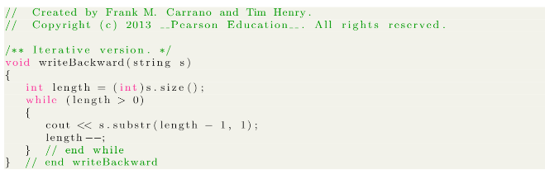

Q2 Write an iterative function for a computing a product of an integer from 1 to n.

Q3 Write a function to compare two singly linked list. Each node of the linked list is defined as follows

struct node {

char c;

node *n;

}

The declaration of the function is given below

Bool compare ( node * head_1, node * head_2);